Structure and properties of carbon blacks

L. Čaplovič (a), M.Beňadik (a)

(a) Faculty of Materials Science and Technology, Slovak Technical University, 812 37 Bratislava, Slovak Republic

Introduction
Carbon black is generally used as a component in graphite production to modify the electrical and mechanical properties of the electrographite and carbongraphite materials. The smallest unit of carbon black is the aggregate, which appears to be formed by fused together spherical particles. Aggregates connect through Van der Waals forces into network called agglomerates.
Graphite-like, quasicrystalline domains, in which basal planes are parallel but angularly distorted and the spacing between the layers is different from that of pure graphite, have been detected in carbon black particles. Those structures were identified as intermediate between crystalline and amorphous materials. Hereafter, the turbostratic quasi-crystalline domains are referred to as graphitic crystallites or nanocrystallites. The layer stacking disorder can be observed in principle by analyzing HK bands in the diffractograms.
The structure of carbon black particles and their surface properties are important for many reasons. The sizes of graphitic crystallites have been estimated from X-ray diffraction, neutron scattering, atomic force microscopy, and Raman spectroscopy measurements. X-ray diffraction peak profile analysis is a widely used method for the determination of crystallite size and lattice defect structure in crystalline materials [1]. The evaluation procedures are based on the different diffraction order dependence of size and strain broadening. In the simplest case the size broadening is independent while the strain broadening is dependent on the diffraction order.

Results of experimental measurement
The lamp carbon blacks (D101, G, P805 and Carbofin) manufactured by three various world producer were used for determination their structural characteristics.
A conventional θ–2θ diffractometer Philips PW 1710 was used to obtain an overview of the diffractograms from analysed carbon black particles. Co anode and graphite secondary monochromator were used for all experiments. Step mode was 0,05° 2θ / 5 sec and 2θ angle range was 2 to 140°.
Morphology of microstructure and crystalographical features of all kinds of carbon blacks show that considerable changes of morphology have less influence on powder diffractogram patterns.
Homogeneity of the carbon black G was higher as carbon black D101. All analysed powder diffraction patterns showed, that line broadening was connected with turbostratic structure.
Crystalographical features of black were strongly influenced by the turbostratic structure, but differences between individual types of carbon black were minimal. Principal feature change was size factor, Fig 1, Fig 2, Fig 3.

Literature
[1] Ungar, T., Gubicza, J., Ribarik, G., Pantea, C., Zerda, T. W.: Carbon 40 (2002) 929–937
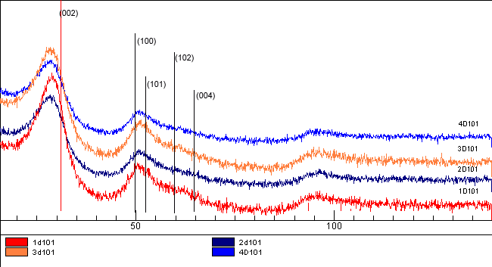
Fig.1. Powder diffractograms for the D101 carbon black specimens

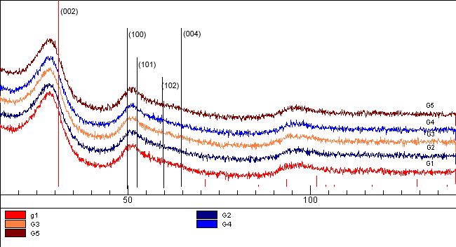
Fig. 2. Powder diffractograms for the G carbon black specimens

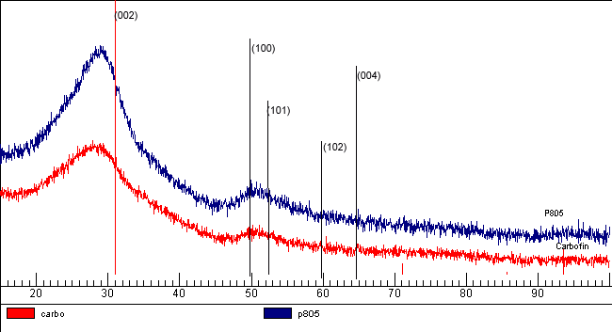
Fig. 3. Powder diffractograms comparision for the Carbofin and P805 specimens

